THE GIVING TRAIN 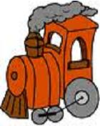

Our Giving Train is loaded for the first time this year. We appreciate any help that you can offer to give us more manipulates, and new media to work with. These same items are also in the Giving Train outside our classroom. If you see something that you would be willing to provide, please get word to me right away (note, e-mail, call) so that I can remove it from the train, and not have duplicates. THANKS IN ADVANCE

Thank you !

